**Section 3: Solidity Coding Tasks (10 pt)**

This section consists of 1 question. Make sure to submit the solidity files with this document. Make sure that the solidity contracts are compiled and runnable. Make sure to add the appropriate comments to the file.

1. The following code snippet consists of a simple auction contract. The highest bidder becomes the new leader of the auction.

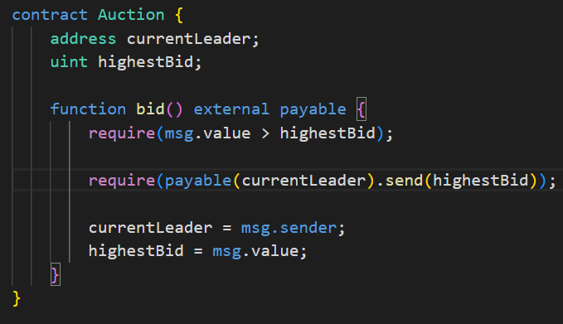

1. Write a solidity smart contract that exploits this auction by preventing any new bidders from becoming the new leader of the auction. (5 pt)
2. Write down several unit tests (in javascript) to confirm that the attacker contract works correctly. (5 pt)